MICROSERVICES INTRODUCTION WITH EXAMPLE PROJECT IMPLEMENTATION
- What Are Microservices?

Microservices is an architectural pattern where we build our application as a collection of small, independent services that:
- Run in their own process
- Communicate via lightweight protocols (HTTP/REST, gRPC, message queues)
Here the message queues are RabbitMQ/Kafka
- They are independently deployable
- They are organized around business capabilities
- Microservices can use different databases and technologies

Example: Instead of one monolithic HRMS application, you'd have separate services:
- Employee Service
- Payroll Service
- Attendance Service
- Leave Management Service

Each service can be developed, deployed, and scaled independently.
• Scalable = able to grow efficiently without making the structure collapse
• Scaling = the act of growing

Learn Dependency Injection in a separate word file

Service Communication Patterns
How microservices talk to each other
- In monolithic application, different modules call each other directly through method calls.
- In microservices, services are separate applications that need to communicate over a network.
- There are 2 types of communication methods synchronous and asynchronous

Asynchronous Communication methods

- Message Queues (RabbitMQ, Azure Service Bus, AWS SQS) – communicates between the application and the server

What is it?
- A middleware that holds messages between services
- Producer puts messages in queue, Consumer reads from queue
- Messages are persistent (survive crashes)
MICROSERVICES E-COMMERCE PROJECT

Yes! Absolutely! 🎯
Here's the complete roadmap of what we'll cover:

📚 Complete Learning Path – 4 phases
✅ Phase 1: Product.API (COMPLETED) - Executed
- RESTful API design
- Repository pattern
- Dependency Injection
- DTOs vs Models
- Swagger documentation
✅ Phase 2: Order.API with HTTP Communication (COMPLETED) - executed
- Service-to-service HTTP calls
- HttpClient with IHttpClientFactory
- Polly (Retry + Circuit Breaker)
- Error handling between services

🔜 Phase 3: Notification.API with RabbitMQ (NEXT)
What You'll Learn:
- Message Queue fundamentals
- RabbitMQ installation (Docker)
- Publisher (Order.API) - Sends messages when order created
- Consumer (Notification.API) - Listens and processes messages
- Asynchronous communication pattern
- Event-driven architecture
Phase 4: API Gateway with Ocelot
What You'll Learn:
- Why API Gateway? (Single entry point)
- Ocelot installation and configuration
- Request routing to microservices
- Load balancing
- Rate limiting
- Authentication/Authorization at gateway
- Request/Response transformation
Phase 5: Apache Kafka (Alternative to RabbitMQ)
What You'll Learn:
- Kafka vs RabbitMQ (When to use which)
- Kafka installation (Docker)
- Topics and Partitions
- Producer/Consumer with Kafka
- Consumer Groups
- Event Streaming vs Message Queuing
- Kafka Connect basics
When to use Kafka:
- High throughput (millions of messages/sec)
- Event streaming and log aggregation
- Real-time data pipelines
- Event sourcing architecture

🔜 Phase 6: Docker & Containerization
What You'll Learn:
- Docker fundamentals
- Creating Dockerfiles for each microservice
- Docker Compose - Running all services together
- Networking between containers
- Volume management for data persistence
- Multi-stage builds for optimization
🔜 Phase 7: SQL Server Database (Real Persistence)
What You'll Learn:
- Entity Framework Core 9 setup
- Code-First migrations
- DbContext configuration
- Database per microservice pattern
- Connection strings management
- Repository pattern with EF Core

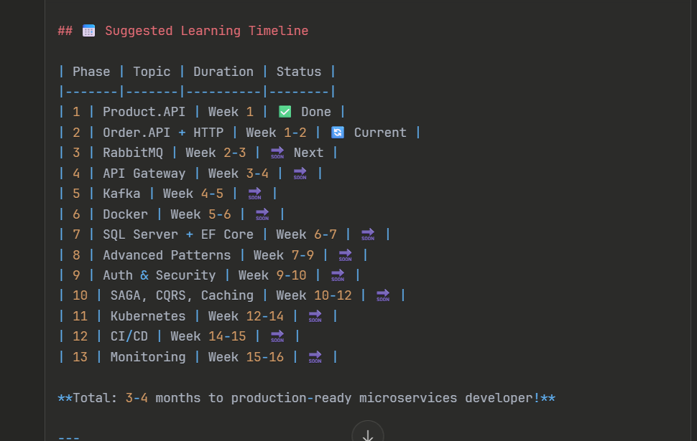

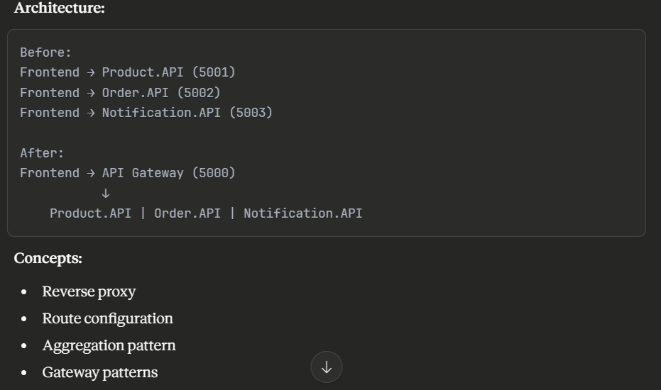

ARCHITECTURE OVERVIEW
We will build 4 microservices
- Product.API(port 5001) – Manages products catalog
- Order.API(port 5002)- Handles orders(calls product.API)
- Notification.API(port 5003) – Sends Notification(uses RabbitMQ)
- API Gateway(port 500) – Single Entry Point (ocelot, yarn etc)

Learning Flow

Phase 1: HTTP/REST Communication (Product + Order)
Phase 2: Add RabbitMQ for Notifications
Phase 3: Add API Gateway Phase – Ocelot
Phase 4: Add Resilience with Polly Phase
Phase 5: Containerize with Docker

- Phase 1: Product.API - Foundation Service
Create a Product API project
• RESTful API Design - Industry standard for service communication
• Dependency Injection - Managing service lifetimes
• Repository Pattern - Separating data access from business logic
• DTOs (Data Transfer Objects) - Controlling what data is exposed
• Logging - Tracking requests across services

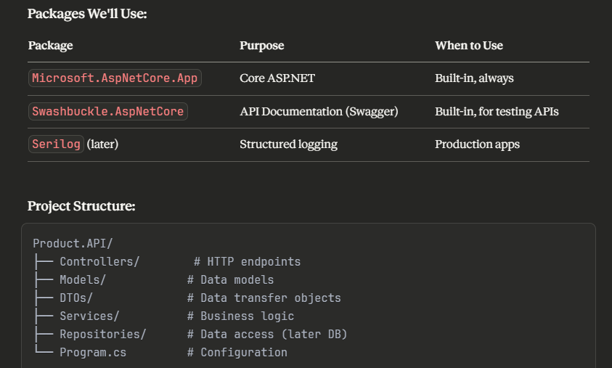

- # Create all folders at once
mkdir Models DTOs Services Repositories Controllers – give this command in the command prompt of the project

- public record ProductDto(
int Id,
int ProductId,
string Name,
string Description,
decimal Price,
int Stock,
string Category,
string? ImageUrl
);
}

Here instead of class we can use Record –
Classes – mutable, that can change, traditional DTO
Record – immutable by default, value based(great for DTOs)

✅ Mutable is Class
Mutable means:
You can change the object after it is created.
❌ Immutable is Record
Immutable means:
You cannot change the object after it is created.
If you want a change, you create a new object.
What is ConcurrentDictionary?

- ConcurrentDictionary<TKey, TValue> - it is a thread-safe collection from System.Collections.Concurrent namespace.
- It allows multiple threads to read and write simultaneously without causing data corruption or race-conditions.
What is the problem with regular dictionary (read in detail)

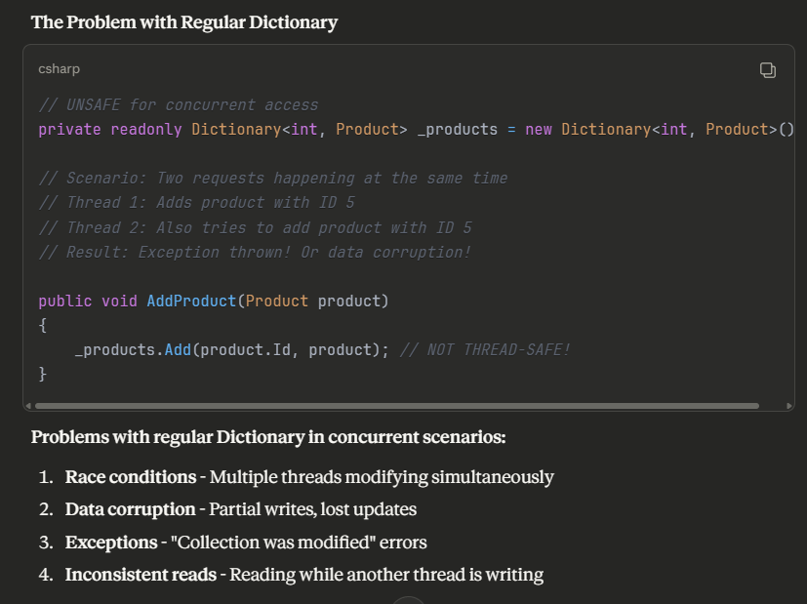
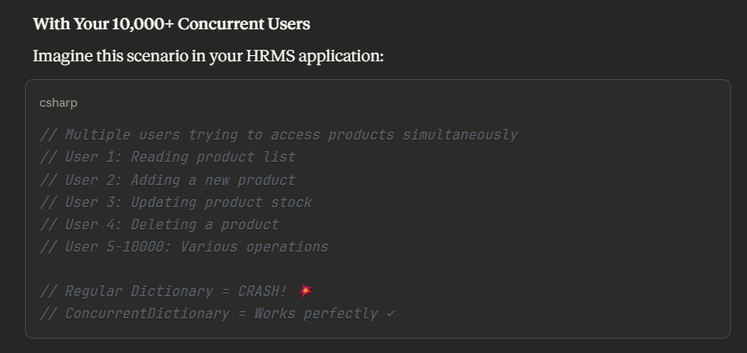

- Concurrent dictionary is a generic collection type
- ConcurrentDictionary<int, Product> - here this is a generic collection with two type parameters.
- // Generic definition: ConcurrentDictionary<TKey, TValue>
// TKey = Type of the Key
// TValue = Type of the Value
- ConcurrentDictionary<int, Product>
- ↑ ↑
- | |
- TKey TValue

From result and Tryaddvalue explanation

What is Task.FromResult?
Task.FromResult<T>() creates an already-completed Task that immediately returns a result. It's used when you need to return a Task<T> but you already have the result available synchronously.

How Task.FromResult Works internally
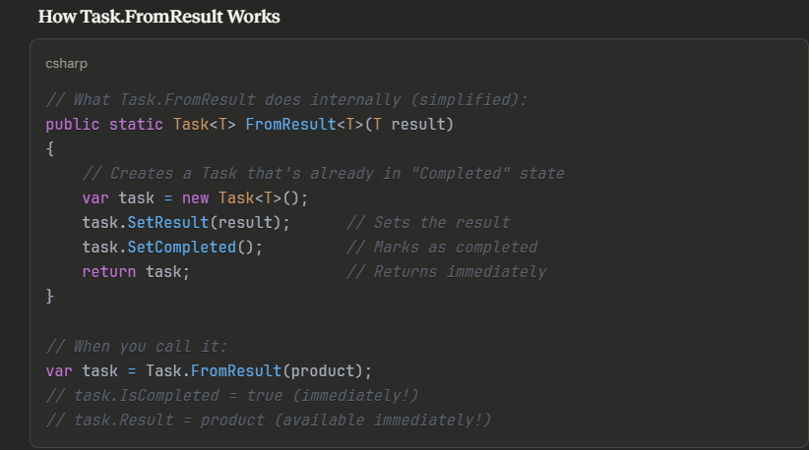
PHASE 2 – ORDER API
What We'll Build:
Order.API will communicate with Product.API to:
- Verify product exists before creating an order
- Check if product has enough stock
- Get product price
- Create order with product details
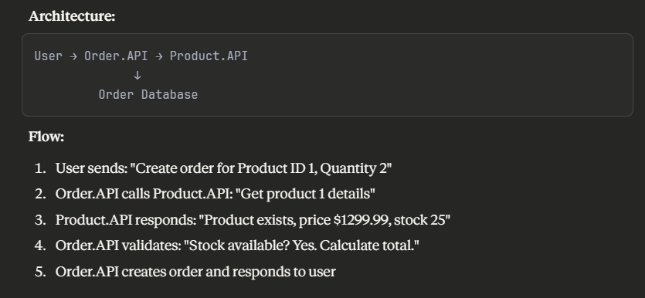

Nuget Packages to be installed for phase 2
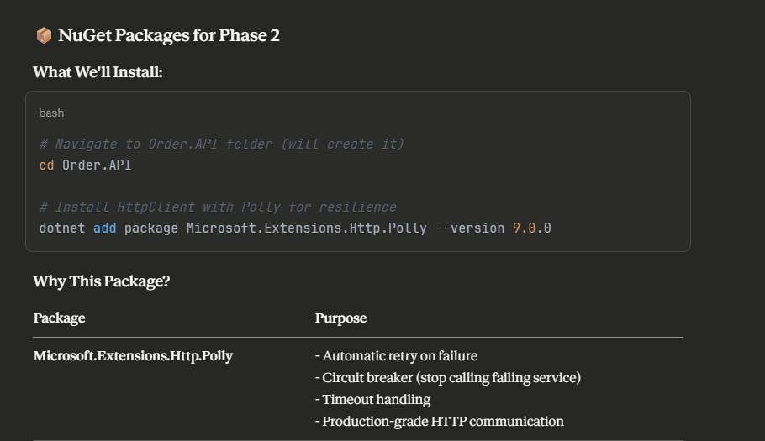

What is Polly?
polly is a resilience(the ability to withstand) library that handles transient failures

circuit breaker is the concept where the failing service temporarily will be stopped calling so that the server won’t crash
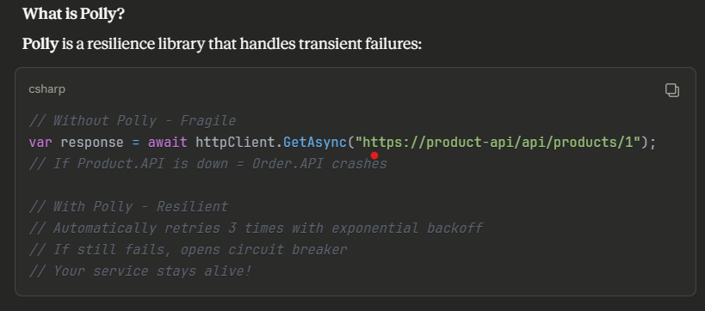

- After installing the polly nuget package manager, create folders
# Create folders
mkdir Models DTOs Services HttpClients Controllers
- HttpClients (new - for calling external APIs) – this is the new folder which is used for calling external APIs

Why abstract keyword is used for BaseEntity.cs model
“abstract” means this class is incomplete and cannot be instantiated directly (that is objects cannot be created from this class properties).

It serves as a base template for other classes to inherit from

Simple Analogy
Think of abstract class like a blueprint or template:
- Abstract class = Blueprint for a house (you can't live in a blueprint!)
- Concrete class = Actual house built from the blueprint (you CAN live here!), that is the objects can be created for the concrete class properties

OrderDetails.cs - Enum concept used for Order status

  - Enum is a powerful feature that makes your code safer and more readable.

What is Enum?
Enum – Enumeration, it is a special data type that represents a fixed set of named constants.
It is used when a variable can only have one value from a predefined list of options.

Simple Definition
Enum = A list of named values that a variable can have
When you save to a database ,enum is stored as an integer

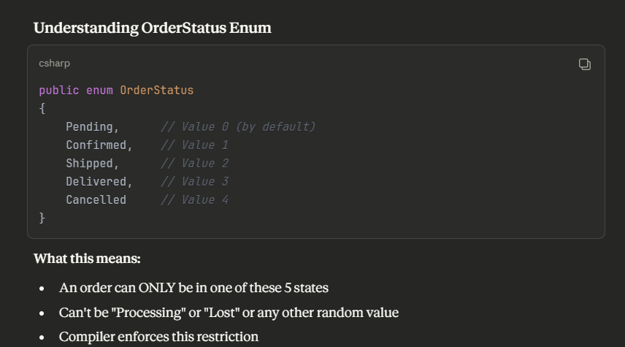

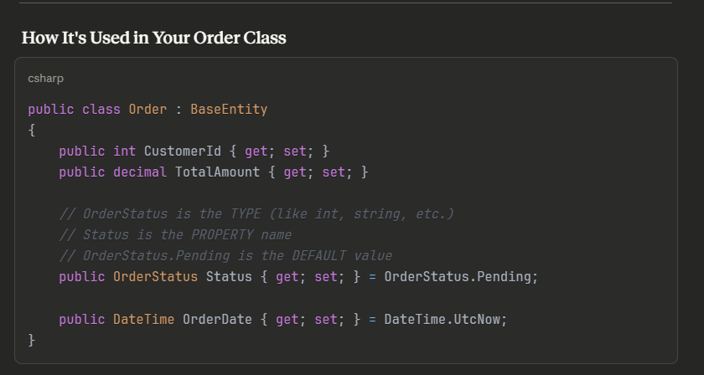

The below image shows how the enumeration is working

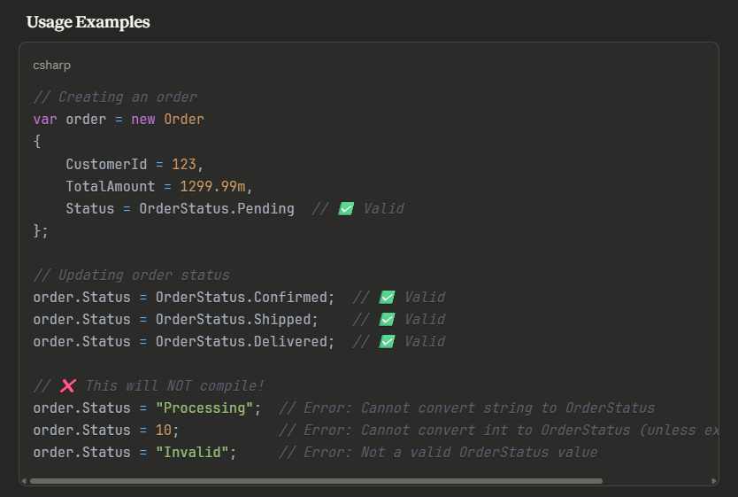

Benefits of enum:
- ✅ Type-safe - Can't use invalid values
- ✅ IntelliSense - Shows available options
- ✅ Compile-time checking - Catches typos
- ✅ Self-documenting - Clear meaning
- ✅ Refactoring-friendly - Easy to rename
- ✅ Cannot be null (by default)
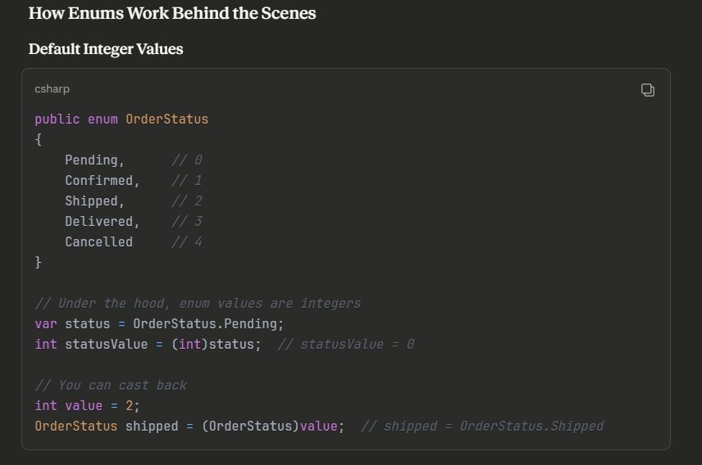

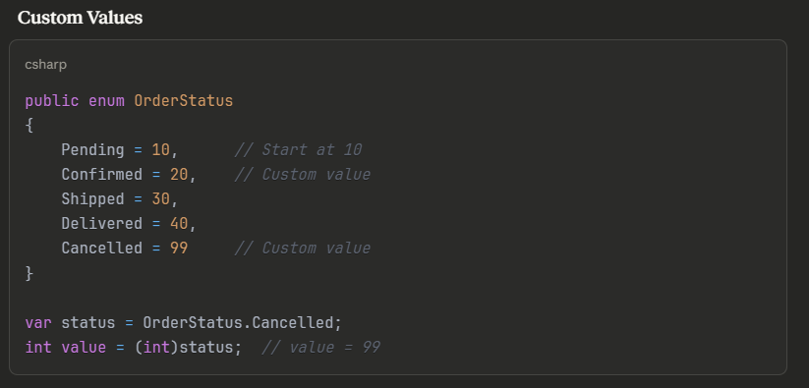

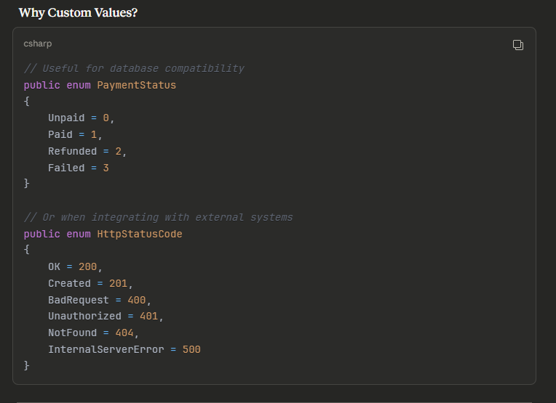

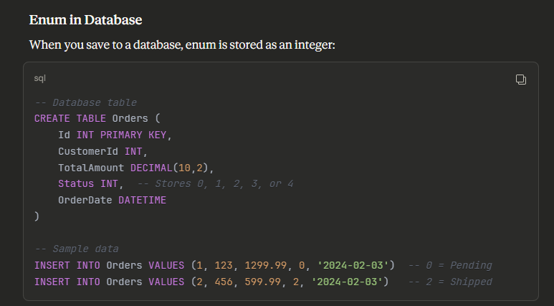

Step wise creation
- Create 2 models class files BaseEntity.cs and OrderDetails.cs
- Create DTO’s , Order Details.cs, ProductDTO.cs , CreateOrderDTO, here the ProductDTO refer to the properties in the Product API, so mention the properties as exactly as metioned in the product api “product.cs” model class
- Create HttpClient for Product.API in the orderAPI project
- Create an interface “IProductHttpClient” under the HttpClient folder of the OrderAPI project
- Here this HttpClient is an interface to call the product API
- Key Points in HttpClient:
Receives HttpClient via constructor - IHttpClientFactory provides it
Base URL configured elsewhere - Not hardcoded here
JsonSerializerOptions - Handles case sensitivity
Error handling - Catches network failures
Logging - Tracks every call for debugging

InMemoryProductRepository – in ProductAPI phase1

Step 1 : public Task<Product?> GetProductByIdAsync(int id)
{
_products.TryGetValue(id, out var product);
return Task.FromResult(product);
}

  - .TryGetValue() Method : This is a safe dictionary lookup method that attempts to retrieve a value by key.
It is a dictionary method, or else for normal ones we would have used firstordefault like that
- Here it returns true if the key exists -> retrieves the values
- Here it returns false if the key doesn’t exist -> sets value to default(null or ref types)

  - Out Keyword : it is a modifier which allows a method to return multiple values
We get additional return values beyond the main return type

Out var – this is the inline declaration of Out parameter
Var – this is the type reference – compiler determines the type automatically

Step 2 : public Task<Product> CreateProductAsync(Product product)
{
//interlocked is a is a static -----classes ,
// Interlocked is a static class in System.Threading that provides atomic operations for variables that are shared by multiple threads.
// It ensures operations complete as a single, uninterruptible unit
product.Id = Interlocked.Increment(ref _nextId);
product.CreatedAt = DateTime.UtcNow;

_products.TryAdd(product.Id, product);

return Task.FromResult(product);
}

What is Interlocked?
Interlocked is a static class in System.Threading that provides thread-safe atomic operations.

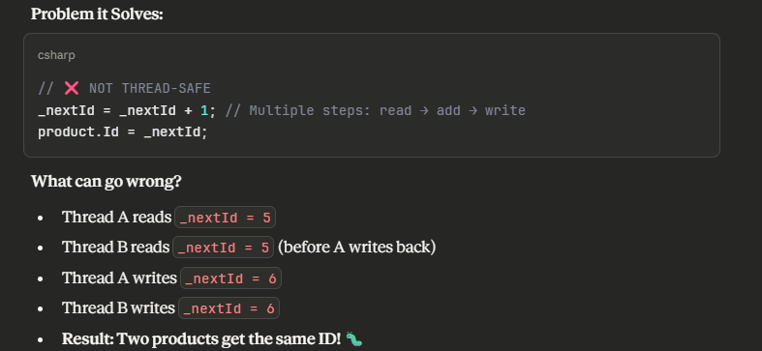

Why Use ref Keyword?
The ref keyword passes a variable by reference and not by value

